TechZone Electronics — Sales Performance Analysis
A Data-Driven Business Case Study

Business Type: Multi-City Electronics Retail Store
Tools Used: Google Sheets | SQL Server | Power BI
Data: Synthetic dataset created to simulate real business scenarios
1. Problem Statement
TechZone Electronics is a mid-sized electronics retail chain operating across 5 Indian cities — Mumbai, Delhi, Bangalore, Chennai and Hyderabad. Despite generating ₹180M in total revenue, the business is experiencing declining profit margins and operational inefficiencies.
The owner has identified 3 core concerns:
- Certain product categories are generating high sales but low or negative profits
- Heavy discounting by sales representatives is eroding margins
- Inventory is poorly managed — some products are critically understocked while others are overstocked
The objective of this analysis is to identify the root causes of these problems and provide actionable recommendations to improve profitability and operational efficiency.

2. Data Overview
- Business: TechZone Electronics (simulated)
- Time Period: January 2023 to December 2024
- Total Records: 1,000 transactions
- Cities Covered: Mumbai, Delhi, Bangalore, Chennai, Hyderabad
- Product Categories: Computing, Display, Mobile, Audio, Appliances
- Total Columns: 21 including Order ID, Date, Product, Category, City, Units Sold, Cost Price, Selling Price, Discount %, Revenue, Profit, Profit Margin %, Stock Available, Stock Status, Customer Type, Sales Rep, Payment Mode and Rating

3. Tools Used
Tool | Purpose
Google Sheets | Data exploration, pivot table analysis
SQL Server (SSMS) | Business queries and aggregation
Power BI | Interactive 3-page dashboard

4. Key Findings
Category Performance:
- Computing is the most profitable category — ₹16.2M profit at 22.39% margin
- Display category has the lowest margin at only 4.74% despite ₹37M revenue — heavy discounting is the cause
- Audio has the highest margin at 24.66% but lowest revenue — an untapped opportunity
City Performance:
- Mumbai is the top performing city — ₹49.5M revenue and 32.87% margin
- Hyderabad is the only loss-making city — -₹1.5M profit despite ₹27M in revenue
- Chennai has very low margin at 5.53% — needs immediate attention
Discount Impact:
- Orders with 0–15% discount are profitable — margins between 15–28%
- Orders with 20% discount show -9.29% margin — loss making
- Orders with 25% discount show -6.32% margin — loss making
- 169 orders were placed at 20%+ discount — costing the business significantly
Inventory Issues:
- Monitor has 5,092 units in stock but only 297 sold — severely overstocked
- LED TV has 4,760 units in stock but only 305 sold — severely overstocked
- Smartphone is at Critical stock — only 173 units remaining with 257 already sold
- Smartwatch is at Critical stock — 217 units remaining with 325 sold
Sales Rep Performance:
- Meera is the top performer — ₹6.7M profit at 19.12% margin
- Amit has the lowest margin at 13.24% despite high order count — likely over-discounting

Seasonal Trends:
- Q4 (Oct–Dec) is the strongest quarter — festive season boost
- September is the only loss-making month — needs seasonal strategy
- January is the lowest revenue month — post festive slump

5. SQL Analysis
Query 1 — Revenue & Profit by Category This query identifies which product categories are profitable and which are losing money.
sql
SELECT Category,
SUM(Revenue) AS Total_Revenue,
SUM(Profit) AS Total_Profit,
ROUND((SUM(Profit)/SUM(Revenue))*100, 2) AS Total_Profit_Margin,
SUM(Units_Sold) AS Total_Units
FROM techzone_sales
GROUP BY Category
ORDER BY Total_Revenue DESC;

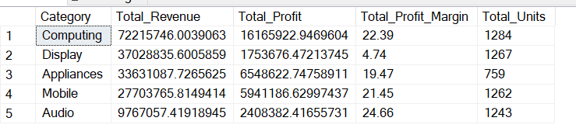
Query 2 — City Performance This query compares revenue, profit and margin across all 5 cities.
sql
SELECT City,
SUM(Revenue) AS Total_Revenue,
SUM(Profit) AS Total_Profit,
ROUND((SUM(Profit)/SUM(Revenue))*100, 2) AS Profit_Margin,
COUNT(Order_ID) AS Total_Orders
FROM techzone_sales
GROUP BY City
ORDER BY Total_Profit DESC;

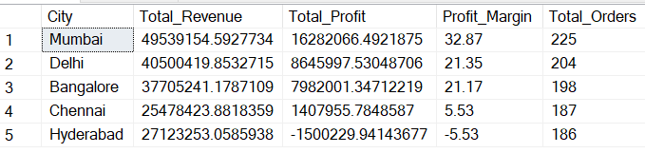

Query 3 — Discount Impact on Profit This query shows how increasing discount percentages affect profit margins.
sql
SELECT Discount_Pct,
COUNT(Order_ID) AS Total_Orders,
ROUND(SUM(Revenue), 2) AS Total_Revenue,
ROUND(SUM(Profit), 2) AS Total_Profit,
ROUND((SUM(Profit)/SUM(Revenue))*100, 2) AS Profit_Margin
FROM techzone_sales
GROUP BY Discount_Pct
ORDER BY Discount_Pct ASC;

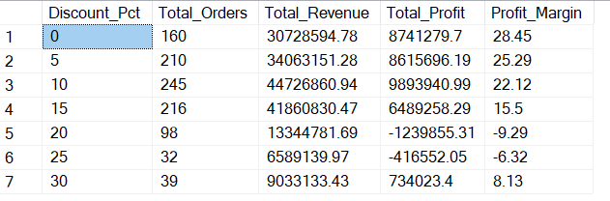
Query 4 — Inventory & Stock Analysis This query identifies overstocked and critically understocked products.
sql
SELECT Product, Category,
SUM(Stock_Available) AS Total_Stock,
SUM(Units_Sold) AS Total_Sold,
Stock_Status,
ROUND((SUM(Profit)/SUM(Revenue))*100, 2) AS Profit_Margin
FROM techzone_sales
GROUP BY Product, Category, Stock_Status
ORDER BY Total_Stock DESC;
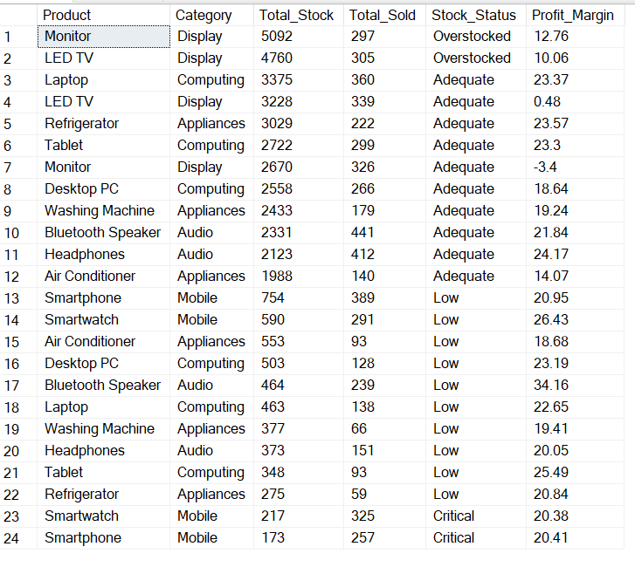
Query 5 — Monthly Sales Trend This query shows revenue and profit trends across all 12 months.
sql
SELECT Month, Quarter,
ROUND(SUM(Revenue), 2) AS Total_Revenue,
ROUND(SUM(Profit), 2) AS Total_Profit,
SUM(Units_Sold) AS Total_Units
FROM techzone_sales
GROUP BY Month, Quarter
ORDER BY MIN(MONTH(Date)) ASC;
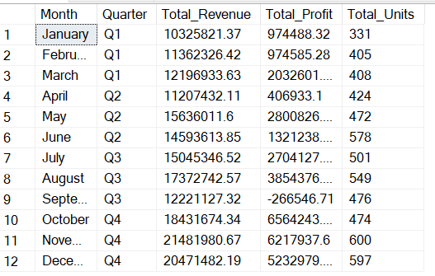
Query 6 — Top & Bottom Products This query identifies the best and worst performing products by profit.
sql
SELECT TOP 3 Product,
ROUND(SUM(Revenue),2) AS Revenue,
ROUND(SUM(Profit),2) AS Profit,
ROUND((SUM(Profit)/SUM(Revenue))*100,2) AS Margin
FROM techzone_sales
GROUP BY Product
ORDER BY Profit DESC;

SELECT TOP 3 Product,
ROUND(SUM(Revenue),2) AS Revenue,
ROUND(SUM(Profit),2) AS Profit,
ROUND((SUM(Profit)/SUM(Revenue))*100,2) AS Margin
FROM techzone_sales
GROUP BY Product
ORDER BY Profit ASC;

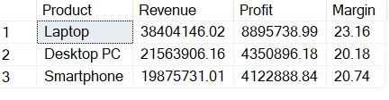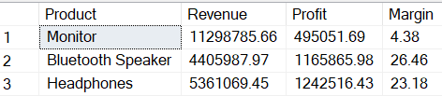

Query 7 — Sales Rep Performance This query evaluates each sales representative's revenue, profit and margin.
sql
SELECT Sales_Rep,
COUNT(Order_ID) AS Total_Orders,
ROUND(SUM(Revenue),2) AS Total_Revenue,
ROUND(SUM(Profit),2) AS Total_Profit,
ROUND((SUM(Profit)/SUM(Revenue))*100,2) AS Profit_Margin
FROM techzone_sales
GROUP BY Sales_Rep
ORDER BY Total_Profit DESC;

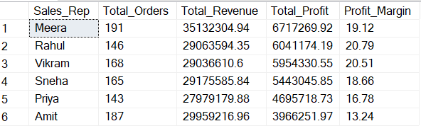
Query 8 — Customer Type Analysis This query compares revenue and satisfaction ratings across customer types.
sql
SELECT Customer_Type,
COUNT(Order_ID) AS Total_Orders,
ROUND(SUM(Revenue),2) AS Total_Revenue,
ROUND(AVG(Rating),2) AS Avg_Rating
FROM techzone_sales
GROUP BY Customer_Type
ORDER BY Total_Revenue DESC;

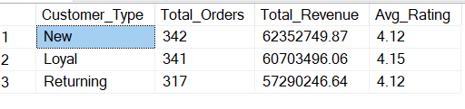

6. Dashboard Overview
The dashboard consists of 3 interactive pages:
- Page 1 — Business Overview: KPI cards, monthly trend, category and product performance
- Page 2 — Profitability Analysis: discount impact, city comparison, sales rep performance, stock status
- Page 3 — Executive Summary: problem KPIs, key findings and recommendations

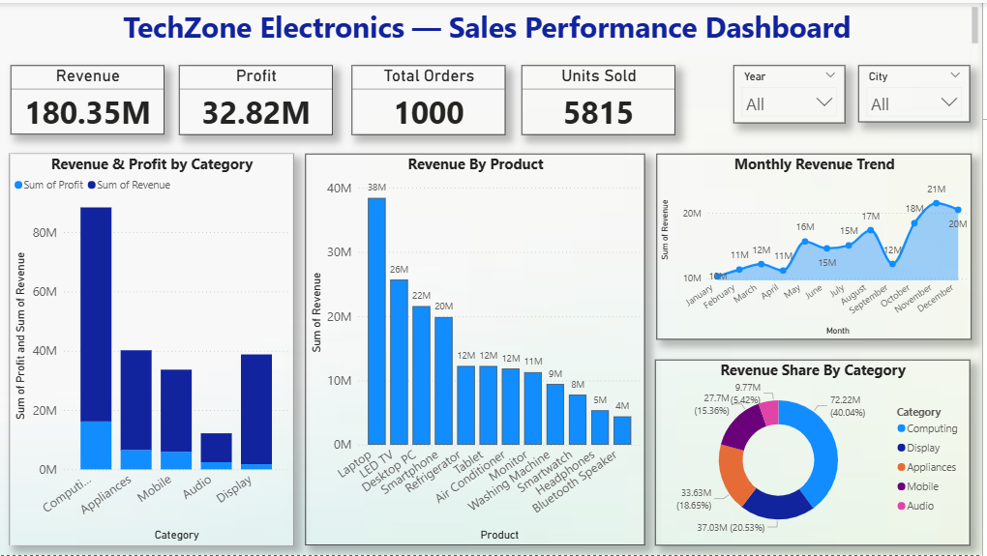

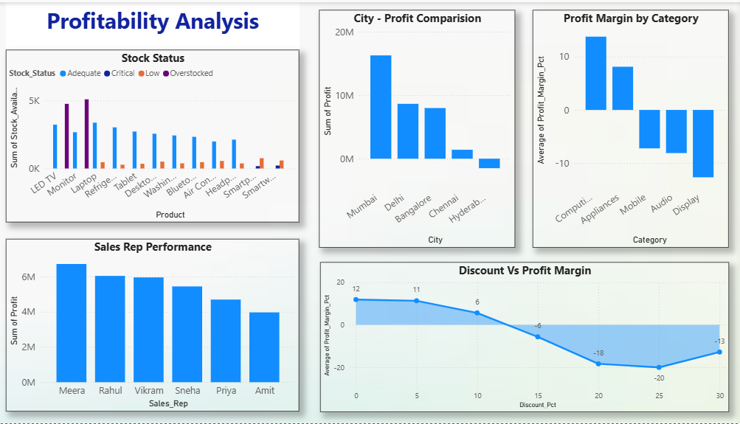

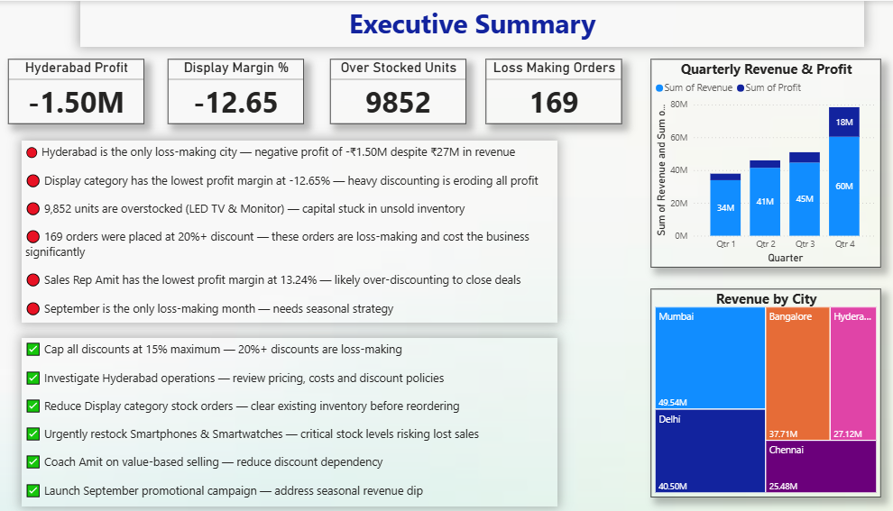

7. Recommendations
Finding | Recommendation | Expected Impact
20%+ discounts are loss-making | Cap all discounts at 15% maximum | Recover ₹1–2M in lost margins
Hyderabad has negative profit | Review pricing and discount policies in Hyderabad | Turn city profitable
Monitor & LED TV overstocked | Pause new orders, run clearance campaigns | Free up ₹5–8M in tied capital
Smartphone & Smartwatch critical | Urgently restock these high-margin products | Recover lost sales opportunity
Amit has lowest margin | Sales training on value-based selling | Improve margin by 5–7%
September loss-making | Launch targeted September campaign or bundle offers | Convert loss month to profitable
Audio has highest margin but low revenue | Increase Audio marketing and shelf space | Boost overall profitability

8. Conclusion
This analysis of TechZone Electronics reveals that the business has a strong revenue base of ₹180M but is losing significant profit due to three key issues — excessive discounting, poor inventory management and underperforming city operations.
By implementing the recommended discount cap, inventory rebalancing and city-specific strategies, TechZone can realistically improve its overall profit margin from the current 18.2% to 22–25%, representing an additional ₹7–12M in annual profit.
Data-driven decision making — rather than intuition-based discounting and stocking — is the key to sustainable growth for TechZone Electronics.

